Computer Language Coding Concepts

Executable Command Object Redirection in a Diagram
The concept of execution object redireciton is explained in the article Execution Object Redirection. The current article explains its expression in a diagram.

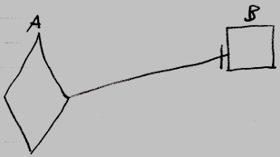

Active command symbol A is a diamond shape, because it is an active command. Active command symbol A redirects its object to the inactive command symbol B. Symbol B is a square because it is an inactive command. The redirection from command A to command B is displayed as a solid line, which is an object line. This makes symbol A an execution of something that is supposed to be a command definition.

You can also object redirect an executable command to another executable command, to keep a reference to a runnable or running command somewhere else.

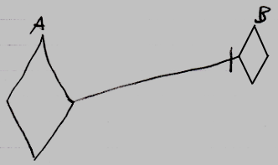

See also: Execution Object Redirection, Commands

Author & Copyright: Jan-Joost van Zon Date: August 10, 2008 – August 15, 2008 Location: Oosterhout, The Netherlands Status: Finished

